C++ POinter Demo:

Pointers

1. Start our program
   1. Start Visual Studio
   2. Create a new empty C++ project:
   3. Call it “PointerDemo”, pick the desktop as the location and click OK.
   4. Click on Source Files and Add|New Item:

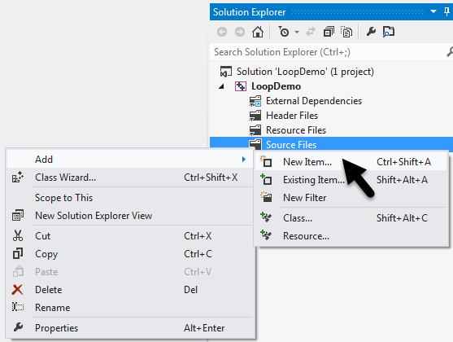

* 1. Select Visual C++, C++ File (.cpp), call it “PointerDemo”, then click “Add”:

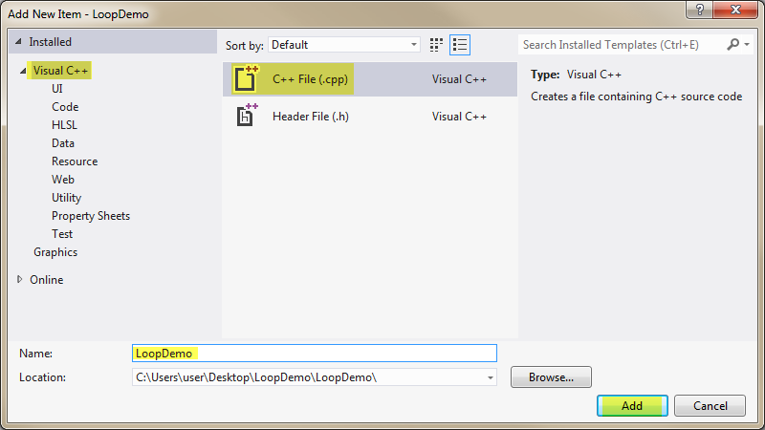

* 1. Enter the following code to start our program:

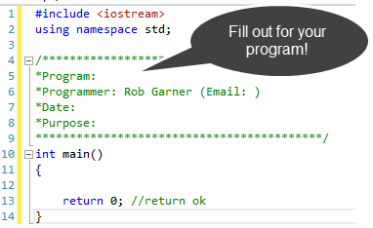

1. Demo pointers:
   1. Enter the following code:

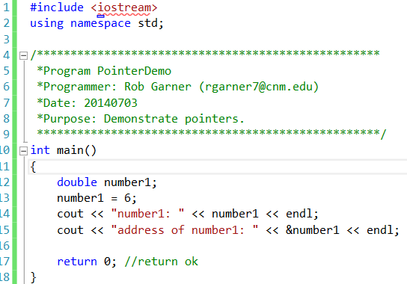

* 1. Try it with Ctrl-F5:

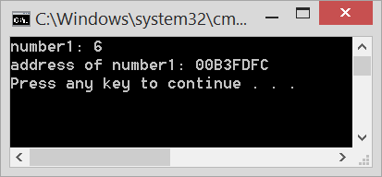

* 1. Add the following code:

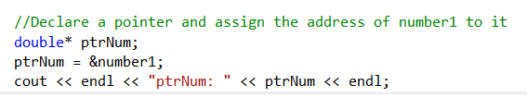

* 1. Try it with Ctrl-F5:

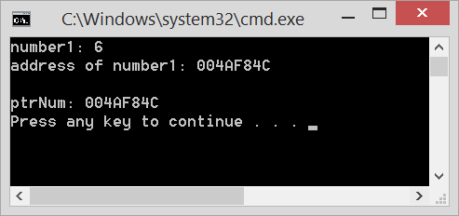

* 1. Notice that the value stored at ptrNum is in fact the address of number1!

# Function that returns one value:

* 1. Change the code as follows:

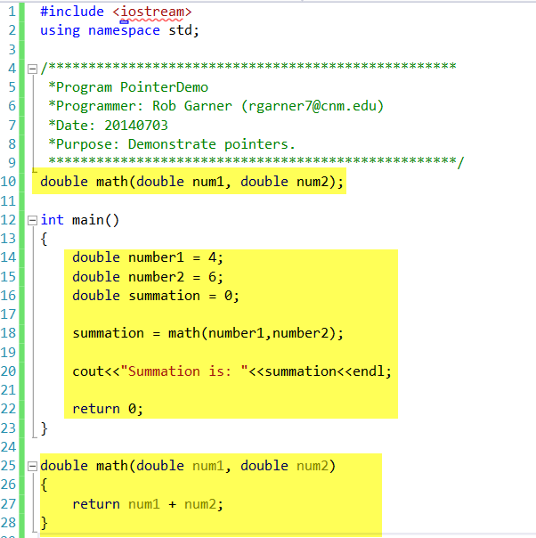

* 1. Try it with Ctrl-F5:

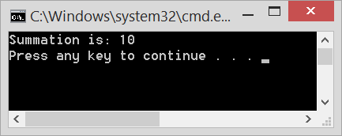

1. Returning more than one value with a function:
   1. Change the code again:

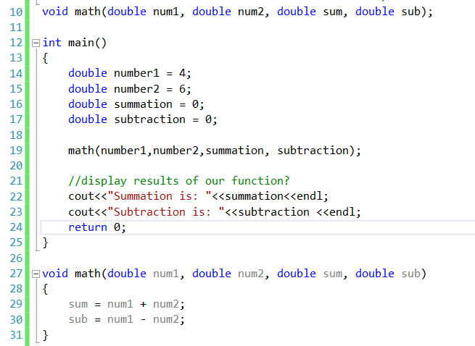

* 1. Try it with Ctrl-F5:

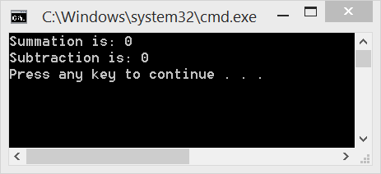

* 1. Notice that we don’t get the sum or subtraction! Why?
  2. Make the following changes:

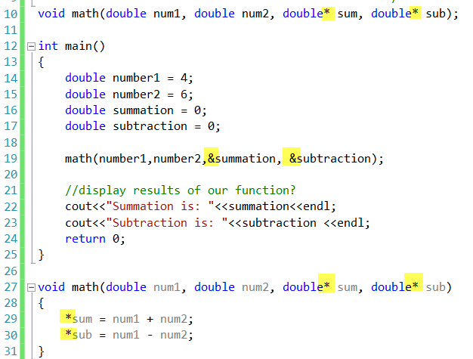

* 1. Try it with Ctrl-F5:

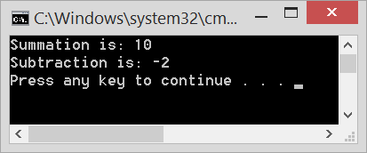

* 1. It now works! Why?

# Code:

#include <iostream>

using namespace std;

/***************************************************

*Program PointerDemo

*Programmer: Rob Garner (rgarner7@cnm.edu)

*Date: 20140703

*Purpose: Demonstrate pointers.

***************************************************/

void math(double num1, double num2, double *sum, double *sub);

int main()

{

double number1 = 4;

double number2 = 6;

double summation = 0;

double subtraction = 0;

math(number1,number2,&summation, &subtraction);

//display results of our function?

cout<<"Summation is: "<<summation<<endl;

cout<<"Subtraction is: "<<subtraction <<endl;

return 0;

}

void math(double num1, double num2, double *sum, double *sub)

{

*sum = num1 + num2;

*sub = num1 - num2;

}